Title of the Paper should be 12 points, Bold, Times New Roman font

ABSTRACT (10, BOLD, CAPITAL, Times New Roman)
A concise and factual abstract is required (maximum length of 250 words). The abstract should have a self-contained, citation-free abstract and state briefly the purpose of the research, methodology, key results and major conclusions. The abstract should be in a single paragraph with running sentences. Do not use any subheadings or point lists within the abstract. Also, non-standard or uncommon abbreviations should be avoided, but if essential they must be defined at their first mention in the abstract itself. (Body Text font size should be 10, Times New Roman, Single Spacing, Justified.)

Keywords: Immediately after the abstract, a maximum of 5 keywords, avoiding general and plural terms and multiple concepts (avoid, for example, 'and', 'of') should be provided. The keywords should be arranged in alphabetical order.

Introduction
Generally, Documents begin with an introduction. It contains a brief idea of the work, the requirement for this research work, the problem statement, and the Author’s contribution to their research. Adequate latest reference citations should be included for showing the prevailing challenges and importance of recent work. This section should be concise, with no subheadings unless unavoidable. State the objectives of the work and provide an adequate background related to your work, avoiding a detailed literature survey or a summary of the results.

Literature Review
Most of the social science research articles include a literature review. It usually contains the significant contribution of past papers to justify the adopted theory and variables. Further to develop hypotheses. It can be divided into subsections. Literature should be written concisely in detail by maintaining continuity of the texts and cited the original work following APA in-text citation format, e.g., Single authored document (Author’s Surname, 2021); double authored document (1st Author’s Surname & 2nd Author’s Surname, 2021); Multiple authored document (1st Author’s Surname, et al., 2021).

Materials and Methods
This part should contain adequate detail to reproduce reported data. It can be divided into subsections to demonstrate data type and collection, and also if several methods are described. Methods already published should be indicated by a reference; only relevant modifications should be described. The methodology should be written concisely in detail by maintaining the continuity of the texts.

Mathematical Expressions and Symbols
Mathematical expressions and symbols should be inserted using the equation tool of Microsoft word. References may be included for used equations to support their authenticity.

$Y=α+β_{1}X_{1}+β_{2}X_{2}+ε$ (1)

Results and Discussion
This section may each be divided by subheadings or may be combined. A combined Results and Discussion section is often appropriate. This should explore the significance of the results of the work, don’t repeat them. Avoid extensive citations and discussion of published literature only; instead discuss recent literature for comparing your work to highlight the novelty of the work in view of recent development and challenges in the field.

Preparation of Figures and Tables
Please note that the article will be published in black and white. Present tables and figures within the article, not at the end of the article. Tables should be numbered consecutively using Arabic numbering (Table 1, Table 2, etc.) and must have corresponding references in the main text. Tables should also have appropriate and concise headings. All figures and illustrations, as in the case of tables, should be numbered consecutively as ‘Figures’ (Figure 1, Figure 2, etc.) with corresponding references in the main text. Figures should also have appropriate and concise headings.
Authors are supposed to embed all figures and tables in the appropriate place within the manuscript. Figures and tables should not be submitted in separate files or at the end of the manuscript. Figures and Tables should be numbered properly with a descriptive title. Each Figure/Table must be explained within the text by referring to corresponding figure/table number. Any unexplained or unnumbered Figure/Table may cause rejection of the paper without being reviewed.

Formatting Tables and figures
Table should be prepare using table tool within the Microsoft word and cited consecutively in the text. Every table must have a descriptive title and if numerical measurements are given, the units should be included in the column heading. Formatting requirement has been summarized in the Table 1.
Table 1: Summary of formatting requirement for Manuscript in this journal.
Layout | Size | Margin (Normal) | Header | Footnote
Single column | A4 (8.27” X 11.69”) | Top=1”  Bottom=1”  Left=1”  Right=1” | Do not add anything in the header | Add Authors’ details in the footnote
Font | Article Title | Headings | Subheadings | Reference list | Text
 | Times New Roman, 12 pt, Bold, centred | Times New Roman, 10 pt, Bold, Left aligned, Capitalized | Times New Roman, 10 pt, Bold, Left aligned | Times New Roman, 10 pt, | Times New Roman, 10 pt, Justified
Line Spacing | 1.0 | 1.0 | 1.0 | 1.0 | 1.0
Page number | We will format and assign page numbers

Formatting Figures
All figures should be cited in the paper in a consecutive order, author may be asked to provide separate files of the figure. Figures should be used in bitmap formats (TIFF, GIF, JPEG, etc.) with 300 dpi resolution at least unless the resolution is intentionally set to a lower level for scientific reasons. If a bitmap image has labels, the image and labels should be embedded in separate layer. Figure 1 shows the logo of E-palli Publisher.

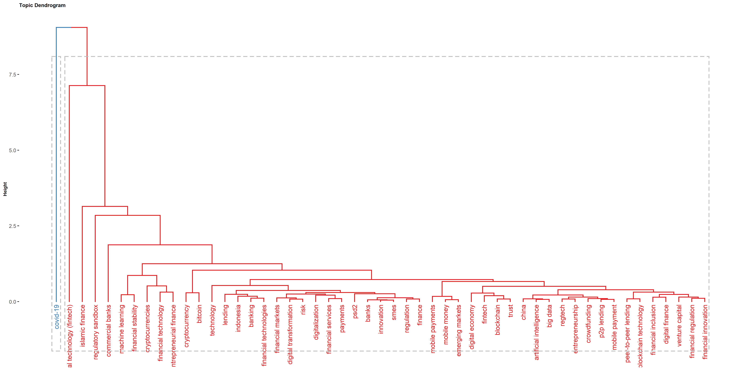
Figure 1: Dendrogram of keywords evolution

Conclusions
Each manuscript should include a conclusion section that contain the major outcome of the study, highlighting its importance, limitation, relevance, application and recommendation. Do not use any subheading, citation, references to other part of the manuscript, or point list within the conclusion.

Acknowledgements (if any)
All acknowledgments (if any) should be included in a separate section before the references and may include funding source, supporting grants with grant number, list of peoples who contributed to the work in the manuscript but not listed in the author list.

References (All e-palli journals strictly follow American Psychological Association (APA) citation and referencing style 7th edition.)
Chowdhury, M. A. M., Hasan, R., & Suvo, S. (2021). (Title of paper. Name of Journal in italic, vol(no), pp-pp.
https://doi.org/10.22345/ajebi (Journal article)
Max-neef M., Elizalde, A., & Hopenhayn, M. (1987). Human Scale Development (S. H. O. Nordberg &
Advisory (eds.)). Dag Hammarskjöld Foundation, Sweden. (Book)
Modigliani, F., & Brumberg, R. (1954). Utility Analysis and the Consumption Function: An Interpretation of
Cross Section Data', In Post Keynesian Economics. (K.K.Kurihara (ed.)). Ruthers University Press. (Book
chapter)
United Nations. (2019). World Population Prospects 2019: Methodology of the United Nations Population
Estimates and Projections. Department of Economic and Social Affairs Population Dynamics. (Report)

